***LEFT AND RIGHT BRAIN THINKING***

*Our brain is divided into two hemispheres- left and right hemisphere by the medial longitudinal fissure. The medial longitudinal fissure (or cerebral fissure, or longitudinal fissure, or interhemispheric fissure) is the deep groove that separates the two hemispheres of the vertebrate brain. The falx cerebri, a dural brain covering, lies within the medial longitudinal fissure.*

*Each side of the brain controls different types of thinking. Additionally, people are said to prefer one type of thinking over the other. For example, a person who is "left-brained" is often said to be more logical, analytical, and objective. A person who is "right-brained" is said to be more intuitive, thoughtful, and subjective.*

*The right brain-left brain theory originated in the work of Roger W. Sperry, while studying the effects of epilepsy (a neurological disorder marked by sudden recurrent episodes of sensory disturbance, loss of consciousness, or convulsions, associated with abnormal electrical activity in the brain.) who was awarded the Nobel Prize in 1981.*

***FUNCTIONS***

*The left hemisphere controls the muscles on the right side of the body and is the more academic and logical side of the brain while the right hemisphere controls those on the left and is the more artistic and creative side of the brain. Therefore damage to the left side of the brain, for example, might have an effect on the right side of the body. Generally, the left side of the brain tends to control many aspects of language and logic, while the right side tends to handle spatial information and visual comprehension.*

*The right brain-left brain theory originated in the work of Roger W. Sperry, while studying the effects of epilepsy (a neurological disorder marked by sudden recurrent episodes of sensory disturbance, loss of consciousness, or convulsions, associated with abnormal electrical activity in the brain.) who was awarded the Nobel Prize in 1981.*

***THE RIGHT BRAIN***

*The right hemisphere specializes in the "softer" aspects of life. This includes intuition, feelings and sensitivity, emotions, daydreaming and visualizing, creativity (including art and music), color, spatial awareness, first impressions, rhythm, spontaneity and impulsiveness, the physical senses, risk-taking, flexibility and variety, learning by experience, relationships, play and sports, humor, motor skills, the left side of the body, and a holistic way of perception that recognizes patterns and similarities and then synthesizes those elements into new forms.*

* *Sees, thinks and processes information in whole, concrete images, therefore, it does not use a step-by-step method to reach a conclusion.*
* *The right brain is reality-based because it thinks in whole, concrete images; that is, it thinks in whole pictures and does not think in the abstract or parts. Therefore, it cannot work easily with abstract symbols like words and numbers.*
* *Thinks multi-dimensionally, or comprehending a subject on many different analytical levels. Therefore, a right-brained person will not fully understand a concept until all aspects of the subject are put together to form the whole image or conclusion.*
* *Thinks emotionally, intuitively, creatively, globally and analytically*
* *Reacts best to visual images, oral discussions and handling objects*
* *May excel in music, art, drawing, athletics and coordinated physical movement.*
* *May be naturally mechanically-minded always taking things apart, repairing or improving them without instruction or even coming up with new inventions.*
* *Remembers faces, places and events very well but not the names.*
* *May have a photographic memory for images, reading selections, oral discussions, places visited and musical works.*

*According to the left-brain, right-brain dominance theory, the right side of the brain is best at expressive and creative tasks.*

* *Recognizing faces*
* *Expressing emotions*
* *Music*
* *Reading emotions*
* *Color*
* *Images*
* *Intuition*
* *Creativity*

***THE LEFT BRAIN***

*The left hemisphere specializes in analytical thought. The left hemisphere deals with* *hard facts: abstractions, structure, discipline and rules, time sequences, mathematics, categorizing, logic and rationality and deductive reasoning, knowledge, details, definitions, planning and goals, words (written and spoken and heard), productivity and efficiency, science and technology, stability, extraversion, physical activity, and the right side of the body. The left hemisphere is emphasized in our educational system and our society in general, for better or for worse; as Marshall McLuhan speculated, "The day when bureaucracy becomes right hemisphere will be utopia."*

* *Thinks in abstract letters, numbers, written words and formulas*
* *Excels in mathematics, reading, spelling, writing, sequencing and the use of verbal and written language*
* *Logical thinking*
* *Is strongly verbal and reacts best to verbal input*
* *Responds well to phonics when learning to spell and read*
* *Handles sequencing of numbers, letters, words, sentences and ideas easily*
* *Does not need to visualize in whole, concrete images to understand ideas, both concrete and abstract*
* *Sees the parts within the whole first, then arrives at the whole concept of a given idea.*

*The left-side of the brain is considered to be adept at tasks that involve logic, language, and analytical thinking. The left-brain is described as being better at:*

* *Language*
* *Logic*
* *Critical thinking*
* *Numbers*
* *Reasoning*

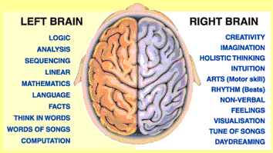

***LATERALIZATION OF THE BRAIN***

*The lateralization of brain function refers to how some neural functions, or cognitive processes (mental action or process of acquiring knowledge and understanding through thought, experience, and the senses) tend to be more dominant in one hemisphere than the other.*

*The term brain lateralization refers to the fact that the two halves of the human brain are not exactly alike. Each hemisphere has functional specializations: some function whose neural mechanisms are localized primarily in one half of the brain.*

*Each hemisphere continues to function semi-independently but their interactions become dominated by one side. That is, each hemisphere always provides its input to the decision-making process but one is drowned out by the other.*

*The medial longitudinal separates the human brain into two distinct cerebral hemispheres, connected by the corpus callosum. Although the macrostructure of the two hemispheres appears to be almost identical, different composition of neuronal networks allows for specialized function that is different in each hemisphere.*

*Lateralization is the idea that the two halves of the brain's cerebral cortex -- left and right -- execute different functions. The lateralization theory -- developed by Nobel-prize-winners Roger Sperry and Robert Ornstein -- helps us to understand our behavior, our personality, our creativity, and our ability to use the proper mode of thinking when performing particular tasks. (The cerebral cortex is a part of the brain that exists only in humans and higher mammals, to manage our sophisticated intellect.)*

*Ideally, we develop "lateralization." This is the use of the proper hemisphere for the task which we are doing. For example, when we are playing a friendly game of softball (a right-hemisphere activity), we would lose the essence of the game -- the fun -- if we were overly apprehensive regarding left-hemisphere matters such as rules and discipline. And when we are balancing our checkbook (a left-hemisphere activity), we don't want to be distracted by the right hemisphere's fascination with creativity and emotions.*

*In every task, one hemisphere is dominant, but the other hemisphere participates to some extent; for example, we do have rules during the softball game, and we can feel happy when we notice that our bills are not as costly this month.*

***CORPUS CALLOSUM***

*The two halves ("hemispheres") are joined by the corpus collosum. The corpus callosum (Latin for "tough body"), also known as the callosal commissure is a wide, flat bundle of more than 200 million nerve fibers about 10 cm long beneath the cortex in the eutherian brain at the longitudinal fissure. These fibers transmit data from one hemisphere to the other so that the two halves can communicate. The corpus collosum is up to 40 percent larger in women than it is in men. It is the largest white matter structure in the brain, consisting of 200–250 million contralateral axonal projections.*

***STRUCTURE***

*The posterior (back) portion of the corpus callosum is called the splenium; the anterior (front) is called the genu (or "knee"); between the two is the truncus, or "body", of the corpus callosum. The part between the body and the splenium is often markedly narrowed and thus referred to as the "isthmus". The rostrum is the part of the corpus callosum that projects posteriorly and inferiorly from the anterior most genu, as can be seen on the sagittal image of the brain displayed on the right. The rostrum is so named for its resemblance to a bird's beak.*

*On either side of the corpus callosum, the fibers radiate in the white matter and pass to the various parts of the cerebral cortex; those curving forward from the genu into the frontal lobe constitute the forceps anterior, and those curving backward into the occipital lobe, the forceps posterior. Between these two parts is the main body of the fibers which constitute the tapetum and extend laterally on either side into the temporal lobe, and cover in the central part of the lateral ventricle.*

*Splenium: The posterior end of the corpus callosum is the thickest part, and is termed the splenium (Greek splenion = a bandage). It overlaps the tela chorioidea of the third ventricle and the mid-brain, and ends in a thick, convex, free border.*

*Genu: The anterior end of the corpus callosum is named the genu, and is bent downward and backward in front of the septum pellucidum; diminishing rapidly in thickness, it is prolonged backward under the name of the rostrum, which is connected below with the lamina terminalis. In a study of five- to eighteen-year-olds there was found to be a positive correlation between age and callosal thickness.*

*Rostrum: The anterior end of the corpus callosum is named the genu, and is bent downward and backward in front of the septum pellucidum; diminishing rapidly in thickness, it is prolonged backward under the name of the rostrum, and is connected below with the lamina terminalis, which stretches from the interventricular foramen to the recess at the base of the optic stalk. The anterior cerebral arteries are in contact with the under surface of the rostrum; they then arch over the front of the genu, and are carried backward above the body of the corpus callosum.*

*On either side of the corpus callosum, the fibers radiate in the white matter and pass to the various parts of the cerebral cortex; those curving forward from the genu into the frontal lobe constitute the forceps anterior, and those curving backward into the occipital lobe, the forceps posterior. Between these two parts is the main body of the fibers which constitute the tapetum and extend laterally on either side into the temporal lobe, and cover in the central part of the lateral ventricle.*

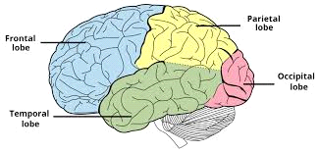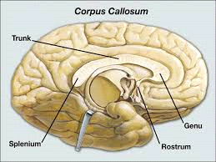

***FUNCTION***

*The primary function of the corpus callosum is to integrate motor, sensory, and cognitive performances between the cerebral cortex on one side of the brain to the same region on the other side- allows communication between both hemispheres.*

*The brain is divided into the right and left hemisphere, and the two halves are connected by the corpus callosum. This bundle of nerve tissue contains over 200 million axons (nerve fibers that carry electrical impulses from neurons’ cell bodies) by rough estimate. This neural tissue facilitates communication between the two sides of the brain.*

*The corpus callosum is the largest collection of white matter within the brain, and it has a high myelin content. Myelin is a fatty, protective coating around nerves that facilitates quicker transmission of information. White matter should not be confused with gray matter. The brain uses gray matter for computation, thinking, memory storage, and more. White matter, like the corpus callosum, allows different parts of the brain to communicate with each other.*

*Some congenital (birth) defects include a complete lack of this neural tissue. In modern neurosurgery, some surgeons have surgically cut the corpus callosum as a means for treating epileptic seizures. By disrupting contact between the two brain hemispheres, a seizure can be isolated and kept from spreading.*

***SYNAPSE***

*The word "synapse" – from the Greek meaning "conjunction", – was introduced in 1897 by the English neurophysiologist Charles Sherrington in Michael Foster's Textbook of Physiology.*

*A junction between two nerve cells, consisting of a minute gap across which impulses pass by diffusion of a neurotransmitter. In the nervous system, a synapse is a structure that permits a neuron (or nerve cell) to pass an electrical or chemical signal to another neuron. Santiago Ramón y Cajal proposed that neurons are not continuous throughout the body, yet still communicate with each other, an idea known as the neuron doctrine. Synapses (at least chemical synapses) are stabilized in position by synaptic adhesion molecules (SAMs) projecting from both the pre- and post-synaptic neuron and sticking together where they overlap; SAMs may also assist in the generation and functioning of synapses.*

*Synapses are essential to neuronal function: neurons are cells that are specialized to pass signals to individual target cells, and synapses are the means by which they do so. At a synapse, the plasma membrane of the signal-passing neuron (the presynaptic neuron) comes into close apposition with the membrane of the target (postsynaptic) cell. Both the presynaptic and postsynaptic sites contain extensive arrays of molecular machinery that link the two membranes together and carry out the signaling process. In many synapses, the presynaptic part is located on an axon, but some postsynaptic sites are located on a dendrite or soma. Astrocytes also exchange information with the synaptic neurons, responding to synaptic activity and, in turn, regulating neurotransmission.*

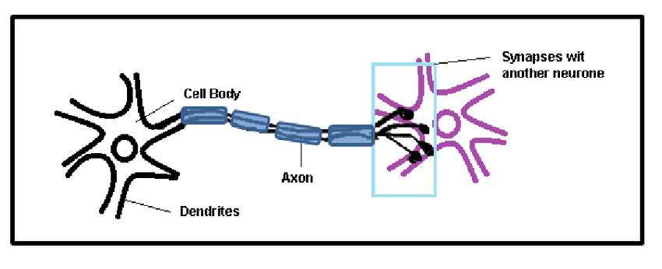

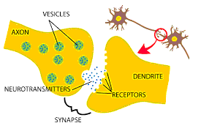

***ROLE IN MEMORY***

*Synapse plays a role in the formation of memory. As neurotransmitters activate receptors across the synaptic cleft, the connection between the two neurons is strengthened when both neurons are active at the same time, as a result of the receptor's signalling mechanisms. The strength of two connected neural pathways is thought to result in the storage of information, resulting in memory. This process of synaptic strengthening is known as long-term potentiation.*